CLOUD STORAGE IMPLEMENTATION
AWS S3 :
It is a cloud storage service provided that can store any amount of data from anywhere.
Example:
Store Files, Backup Data, Host Website, Store image/vedioes, Save application data
How to store data in S3:

🔹 Step 1: Open AWS S3 Service
- Logged into AWS Management Console
- Searched for S3 in the services search bar
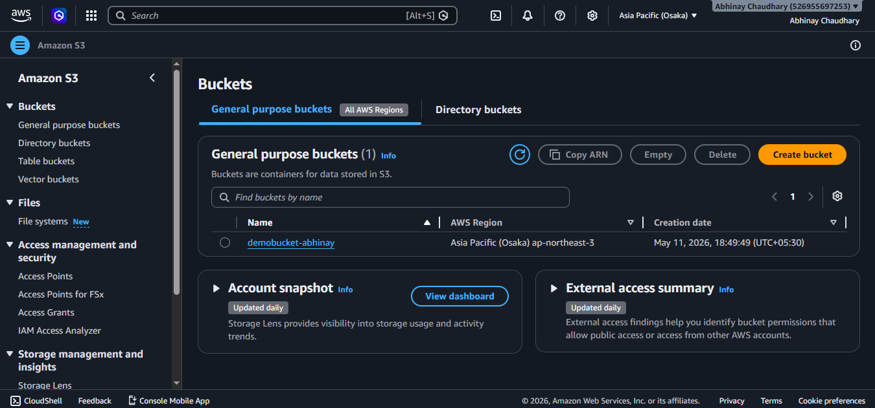
- Opened the Amazon S3 dashboard

🔹 Step 2: Create Storage Bucket
- Clicked Creat Bucket
- Entered unique bucket name
- Selected region
- Kept default settings
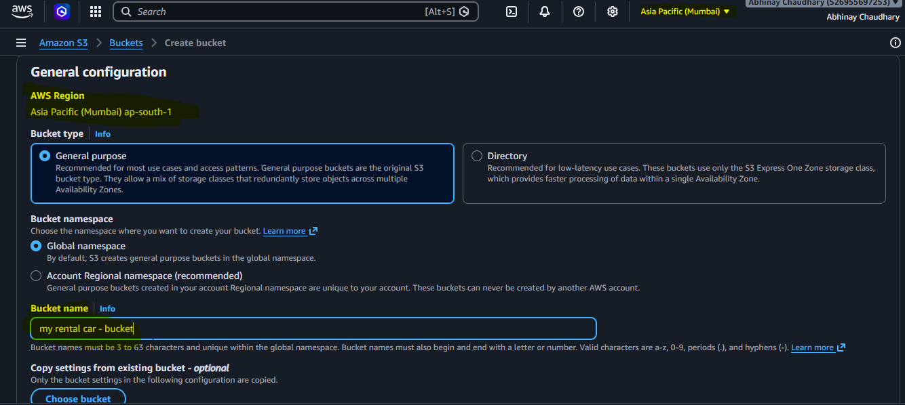

🔹 Step 3: Upload Files
- Opened the created bucket
- Clicked Upload
- Selected files from local system
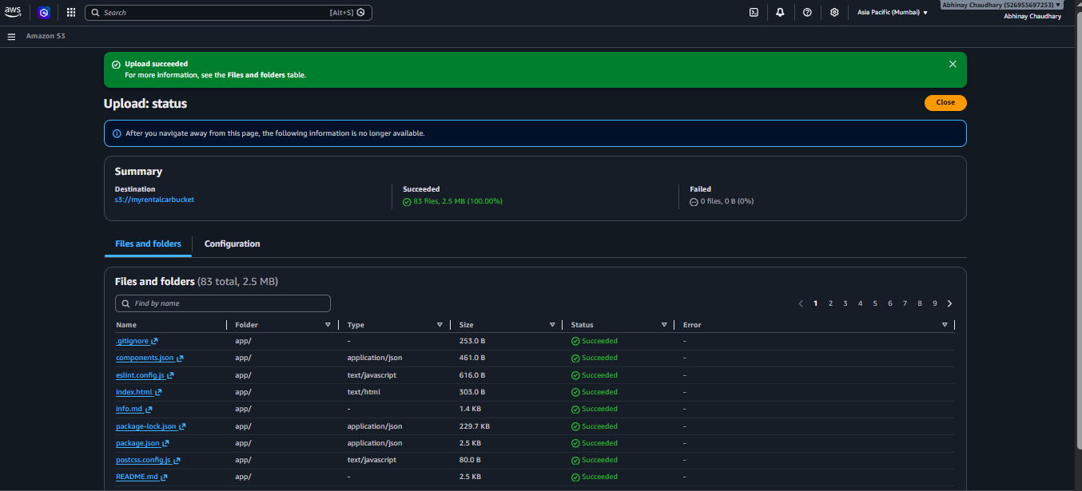
- Successfully uploaded files to S3 bucket

🔒 Public vs Private Access

Public Access
- Files can be accessed by anyone using a URL
- Useful for:
  - Website images
  - Public downloads

Private Access
- Files accessible only to authorized users
- More secure for sensitive data

Observation:
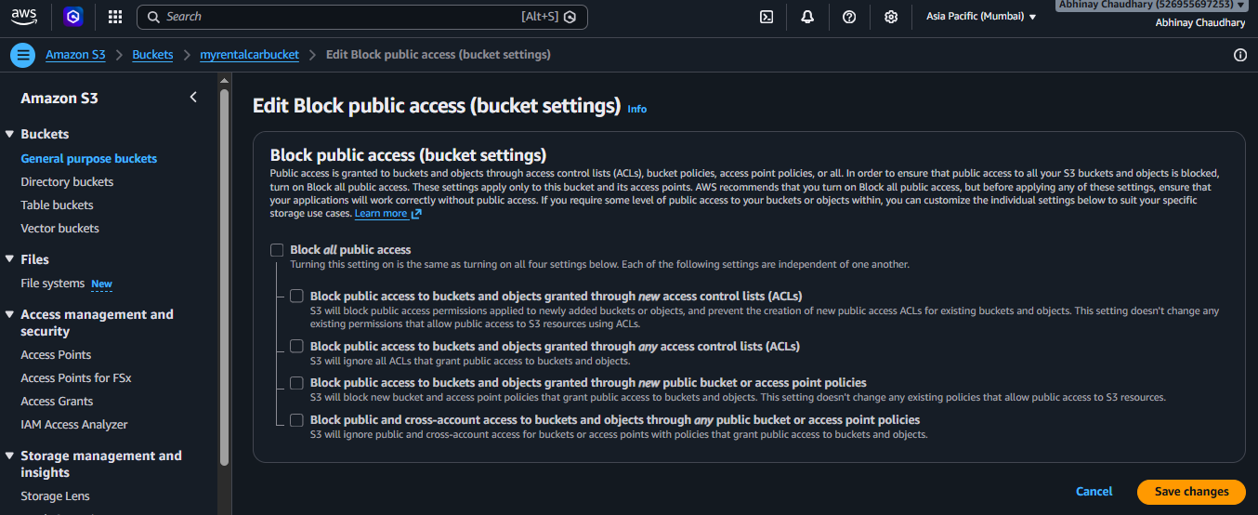
AWS blocks public access by default for security purposes.

🛡️ Permissions & Bucket Policies
Permissions in S3 control who can:
- Read files
- Upload files
- Delete files

Bucket Policies
Bucket policies are JSON-based rules used to manage access permissions.

Example Uses:
- Allow public read access
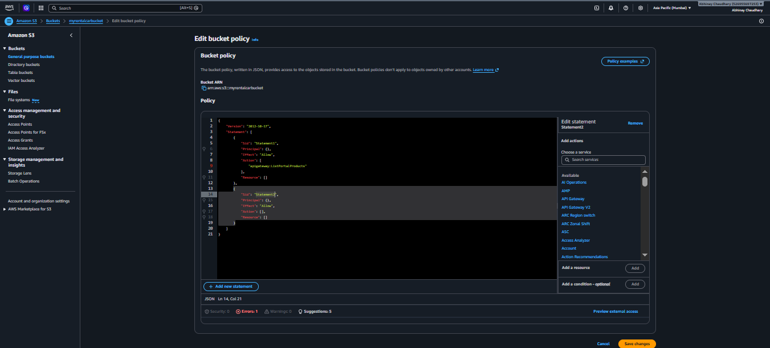
- Restrict access to specific users

🔄 File Versioning
Versioning allows multiple versions of the same file to be stored.

Benefits:
- Recover deleted files
- Restore older versions
- Protect against accidental changes

Steps:
- Open bucket properties
- Enable Versioning
